*Sent to all Members*  
  
August 18, 2024  
  
Dear {%FName%},

Rotary Minutes are provided by District Governor Roger Utnehmer (Oot-name-er).

Please read at club meetings and post in newsletters and social media.

===========================================================

“The reason I’m active in Rotary is because of a girl named Elizabeth. She was a three-year-old girl whose parents asked me to bless her before she died.

It was 1990 and I was living in a shantytown outside Lima, Peru with six Catholic priests from St. Norbert Abbey in DePere, WI.

Many in the neighborhood mistook me for a priest as well. Elizabeth’s parents knew she was seriously ill but could not even afford bus fare to get her to a hospital.

After paying a doctor a small amount of cash, he determined she was simply dehydrated. Within two days Elizabeth was back to her healthy, smiling self.

Today she is a thirty-seven-year-old mother raising a family of her own in Lima.

I keep her picture on my desk as a daily reminder how blessed I am to live in the United States of America.

I consider myself to be among the luckiest people in the world by sheer chance of birth.

Freedom, opportunity, self-determination, electricity at the flip of a switch, and a hot shower at the turn of a knob will never be taken for granted by me after spending two years in South America.

Today part of my heart remains with the poor in Peru. And part embraces Rotary International service.  Rotary is the most effective mechanism to pay-back and pay-it-forward for being gifted and graced with a good life.

If you share my belief that those of us living in the United States of America are among the most fortunate people in our world, please join me in Rotary service.

Recruit a member. Volunteer for a project. Support the Rotary Foundation. Attend a conference or convention.

As for me, there is no better way to express gratitude than Rotary. Because with good fortune comes responsibility.

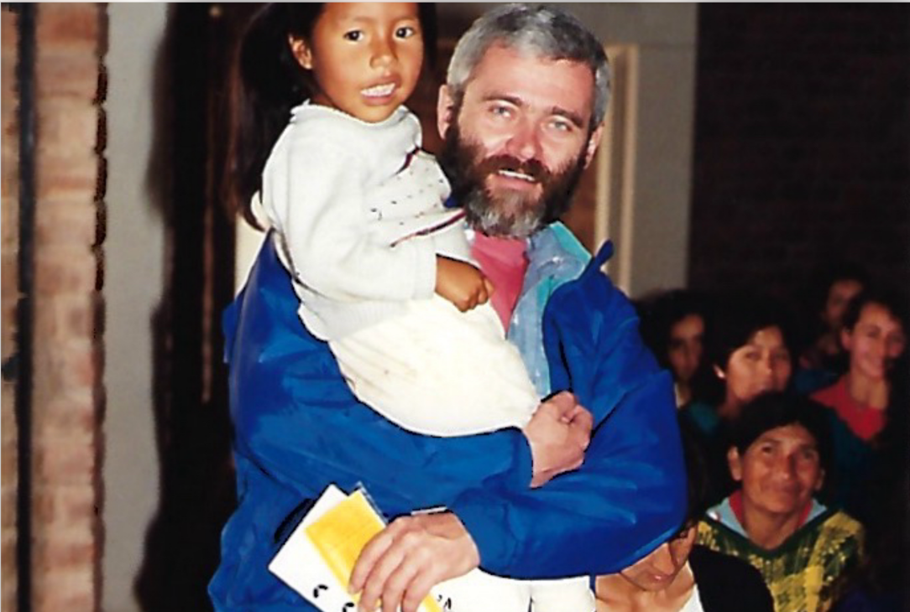

This has been a Rotary Minute.”  
  
ROGER UTNEHMER  
Rotary District 6220  
District Governor 2024-25  
(C) 920 495 9677